Springer Blockchain Use Cases: Chapter Style Guide

Authors must follow these style guidelines when submitting their chapter. Authors who do not follow these guidelines will be requested to revise their initial submission. Subsequent failure to adhere to formatting requirements will result in the author’s submission being rejected. We have provided a sample chapter outline on page 4.

Title
Your chapter title should use the “Title” style used in this guide (e.g. Times New Roman, 14-point bold, all caps). Ensure that the chapter title adheres to the capitalisation style (i.e. “SMART CONTRACTS ENGINEERING” versus “Smart Contracts Engineering”).

Author(s) Details:
First Author Details: Second Author Details:
First Name, Last Name, First Name, Last Name,
Affiliation, Affiliation,
Email Address Email Address

Abstract
Each abstract must be less than 250 words and must concisely describe the scope and content of the chapter. The abstract should outline the chapter’s objective, background information, the methodology and its findings, conclusions and theoretical and/or practical contributions. The abstract should be configured as Times New Roman, 12-point bold, left aligned).

Keywords
Ensure that at least three keywords are provided immediately following your abstract. The keywords should be configured as Times New Roman, 11-point bold, small caps (i.e. business model; literature review; customer).

Length
Submitted chapters must be between 6,000 and 9000 words.

Body Text
Ensure that the body text used is the “Normal” style which is configured as 12-point Times New Roman. Please ensure all text is left-aligned.

Figures and Tables
Place figures and tables close to the relevant text (or where they are referenced in the text). Captions should be placed beneath the figure or table and be configured as Times New Roman, 10-point, centred text).
Captions should also be spelled fully and be suitably numbered (i.e. “Figure 1”, “Figure 2”, “Table 1”, “Table 2” and so on).

Page Size and Spacing
Page margins must be formatted as per the figure below.
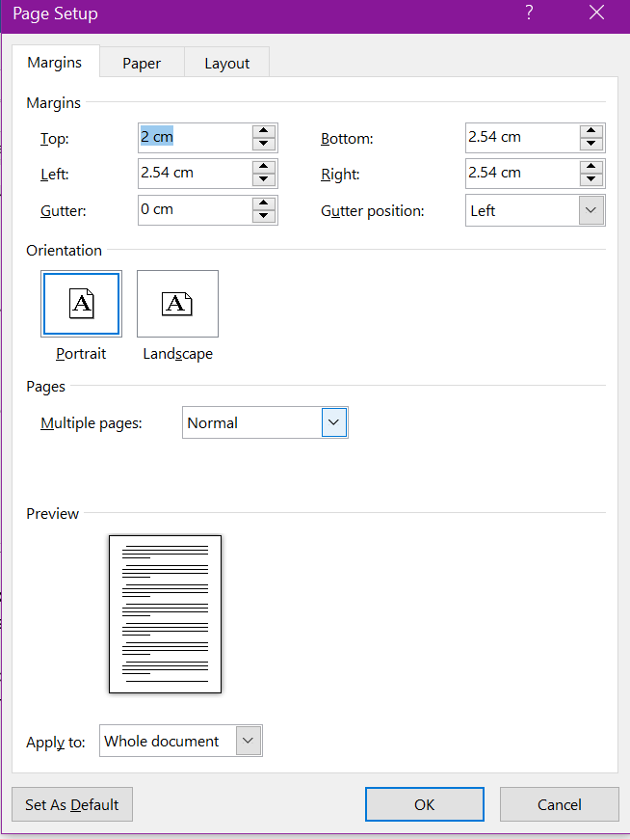

With regards to spacing and text alignment please ensure that your chapter conforms to the following instructions:
- Line spacing should be 1.5 lines (exactly 1.5);
- Spacing between sections and sub-sections headings and body text should use before (11-point) and after (5-point).

Sections
The heading of a section should be configured as Times New Roman 12-point bold, left justified. Sections should not be numbered. Ensure proper the appropriate capitalisation style is used for sections with initial letters capitalized (i.e. “Literature review” versus “Literature Review”).

Sub-sections
The heading of a sub-section should be configured as Times New Roman 12-point italic, left justified. Sub-sections should not be numbered. Ensure proper the appropriate capitalisation style is used for subsections with initial letters capitalized (i.e. “Literature review” versus “Literature Review”).

Language
To ensure suitability for an international audience, please pay attention to the following authors may use any dialect of English (i.e., Canadian, US, British, etc.) provided this is done consistently (i.e. “the organization operationalized” versus “the organisation operationalized”).

Style and Presentation
It is important that authors write for a general audience and present their chapter in a professional manner. This chapter style guide is intended to assist authors in achieving that goal. By adhering to the chapter style guide, you also assist the chapter associate editors tremendously in reducing our workload and ensuring impressive presentation of your chapter paper. We thank you very much for your cooperation.

References
References are to be formatted using the APA style (http://www.bibme.org/citation-guide/apa/). References must be complete, i.e., include, as appropriate, volume, number, month, publisher, city and state, editors, last name & initials of all authors, page numbers, etc. Ensure that references are configured as Times New Roman, 10-point, indentation hanging 1.25 cm.

Toward More Rigorous Blockchain Research:

Recommendations for Writing Blockchain Case Studies

Abstract
About a decade ago the fundamental operating principle of the Blockchain was introduced. It took several years before the technology gained widespread recognition in industry and academic communities outside of the computer science sphere. Since then many academic communities have taken up the topic, but so far no well-defined research agenda has emerged: research topics are scattered and rigorous approaches are scarce. More often than not, use cases implemented by industry apply a trial and error approach and there exists a dearth of theory-based academic papers on the topic following robust methodologies. Being a nascent research topic, case studies on Blockchain applications are a suitable approach to systematically transfer industry experience into research agendas which benefit both theory development and testing as well as design science research. In this paper I offer guidelines and suggestions on how to design and structure Blockchain case studies to create value for academia and the industry. More specifically, I describe Blockchain characteristics and challenges, present existing Blockchain case studies, and discuss various types of case study research and how they can be useful for industry and academic research. I conclude with a framework and a checklist for Blockchain case study research. (Swan, 2015; Treiblmaier and Beck, 2019).
Keywords: Blockchain, Distributed Ledger Technology, Case Studies, Research Framework

Introduction
The emergence of Blockchain publications in leading academic journals has shown a substantial time lag in comparison to industry adoption. Outside of the computer science and cryptography communities, the first academic journal publications discussing Bitcoin appeared around 2012, followed by papers dealing with the Blockchain and DLT (Distributed Ledger Technology) around 2015. This delay has partly to do with lengthy review cycles of top-tier academic journals, but also with the complexity of the technology in combination with poorly understood and unclear use cases. This situation has changed with the emergence of publications targeting a broader audience, in which the authors speculate about potential application scenarios for the technology (e.g., Swan, 2015). Many of the suggested use cases are far-reaching in terms of their potential implications and cover a wide range of industries and applications, including financial services, transportation and supply chain management, media and entertainment, education, tourism, public services, consumer services, voting and academic peer reviews (Önder and Treiblmaier, 2018; Treiblmaier and Beck, 2019).

Blockchain: Definitions, Characteristics and Challenges
The term Blockchain originates from the original description of Bitcoin by the mysterious author (or group of authors) identified as Satoshi Nakamoto (2008). Nakamoto never actually uses the term “Blockchain” in his/her/their seminal paper, but instead describes how transactions, hashes and nonces can be grouped together into a block-based data structure in which the single blocks are chained together by including the hash of a previous block. Since then, the term Blockchain has gained widespread public attention and is most commonly used to denote what can be more loosely described as “trustless systems”, indicating that the amount of trust required of individual actors is minimized.

References: Please ensure that all references cited within the paper are accurate and complete and follow the exemplars outlined below.
Nakamoto, S. (2008). Bitcoin: A Peer-to-Peer Electronic Cash System, Retrieved August 12, 2017 from https://bitcoin.org/en/bitcoin-paper.
Önder, I. and Treiblmaier, H. (2019). Blockchain and Tourism: Three Research Propositions, Annals of Tourism Research, Retrieved from https://doi.org/10.1016/j.annals.2018.03.005.
Swan, M. (2015). Blockchain: Blueprint for a New Economy. Sebastopol, CA, USA: O’Reilly Media.
Treiblmaier, H. and Beck, R. (2019). Business Transformation through Blockchain. Basingstoke, England: Palgrave Macmillan.

