Springer Blockchain Use Cases: Chapter Style Guide

Authors must follow these style guidelines when submitting their chapter. Authors who do not follow these guidelines will be requested to revise their initial submission. Subsequent failure to adhere to formatting requirements will result in the author’s submission being rejected. We have provided a sample chapter outline on page 4.

Title
Your chapter title should use the “Title” style used in this guide (e.g. Times New Roman, 14-point bold, all caps). Ensure that the chapter title adheres to the capitalisation style (i.e. “SMART CONTRACTS ENGINEERING” versus “Smart Contracts Engineering”).

Author(s) Details:
First Author Details: Second Author Details:
First Name, Last Name, First Name, Last Name,
Affiliation, Affiliation,
Email Address Email Address

Abstract
Each abstract must be less than 250 words and must concisely describe the scope and content of the chapter. The abstract should outline the chapter’s objective, background information, the methodology and its findings, conclusions and theoretical and/or practical contributions. The abstract should be configured as Times New Roman, 12-point bold, left aligned).

Keywords
Ensure that at least three keywords are provided immediately following your abstract. The keywords should be configured as Times New Roman, 11-point bold., small caps (i.e. business model; literature review; customer).

Length
Submitted chapters must be between 6,000 and 9000 words.

Body Text
Ensure that the body text used is the “Normal” style which is configured as 12-point Times New Roman. Please ensure all text is left-aligned.

Figures and Tables
Place figures and tables close to the relevant text (or where they are referenced in the text). Captions should be placed beneath the figure or table and be configured as Times New Roman, 10-point, centred text).
Captions should also be spelled fully and be suitably numbered (i.e. “Figure 1”, “Figure 2”, “Table 1”, “Table 2” and so on).

Page Size and Spacing
Page margins must be formatted as per the figure below.
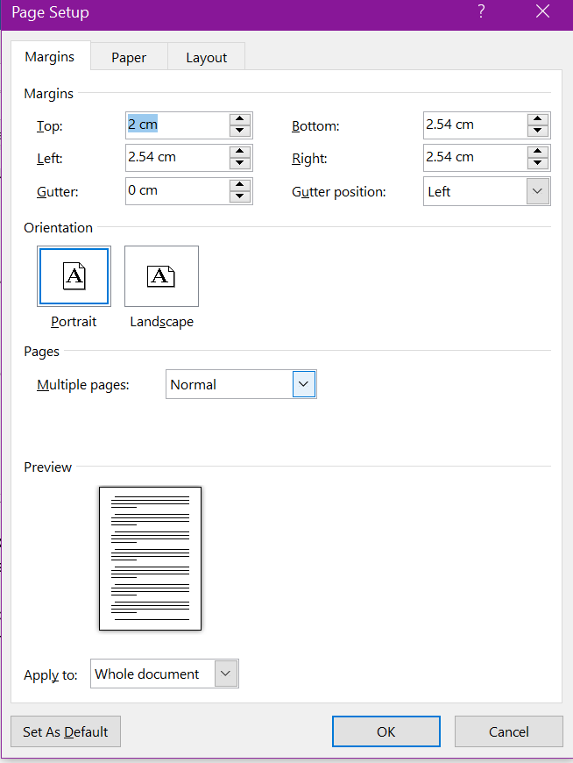

With regards to spacing and text alignment please ensure that your chapter conforms to the following instructions:
- Line spacing should be 1.5 lines (exactly 1.5);
- Spacing between sections and sub-sections headings and body text should use before (11-point) and after (5-point).

Sections
The heading of a section should be configured as Times New Roman 12-point bold, left justified. Sections should not be numbered. Ensure proper the appropriate capitalisation style is used for sections with initial letters capitalized (i.e. “Literature review” versus “Literature Review”).

Sub-sections
The heading of a sub-section should be configured as Times New Roman 12-point italic, left justified. Sub-sections should not be numbered. Ensure proper the appropriate capitalisation style is used for subsections with initial letters capitalized (i.e. “Literature review” versus “Literature Review”).

Language
To ensure suitability for an international audience, please pay attention to the following authors may use any dialect of English (i.e., Canadian, US, British, etc.) provided this is done consistently (i.e. “the organization operationalized” versus “the organisation operationalized”).

Style and Presentation
It is important that authors write for a general audience and present their chapter in a professional manner. This chapter style guide is intended to assist authors in achieving that goal. By adhering to the chapter style guide, you also assist the chapter associate editors tremendously in reducing our workload and ensuring impressive presentation of your chapter paper. We thank you very much for your cooperation.

References
References are to be formatted using the APA style (http://www.bibme.org/citation-guide/apa/). References must be complete, i.e., include, as appropriate, volume, number, month, publisher, city and state, editors, last name & initials of all authors, page numbers, etc. Ensure that references are configured as Times New Roman, 10-point, indentation hanging 1.25 cm.

An Integrated Process Model for Smart Contract Engineering

Abstract
The pseudonymous author (or group of authors) Satoshi Nakamoto, who did not even mention the term “blockchain” in his paper, introduced the cryptocurrency Bitcoin as the first use case of this technology (Nakamoto, 2008). The following years were characterized by intense discussions in academic communities specialized in cryptography and dedicated online groups, but the full potential of this technology was not yet understood fully by applied and business-oriented communities. This situation changed around the year 2014 when the exchange rate of Bitcoin started to soar, and several authors highlighted the potential of the technology for various use cases beyond cryptocurrencies (Swan, 2015; Treiblmaier and Beck, forthcoming; Önder and Treiblmaier, forthcoming).
Keywords: Smart Contract, Development Process Model, Software Engineering, Blockchain, Distributed Ledger Technology, Survey, Design Science

Smart Contracts in Trustless Append-only Decentralized Digital Ledgers
The basic technological properties of trustless append-only decentralized digital ledgers (TADDL), such as blockchain technology, are well-studied and described in the literature (e.g., Tschorsch and Scheuermann, 2016). Several open and active research streams focusing on specific technological issues of TADDLs can be identified, including topics such as anonymity vs. pseudonymity, transaction rates, and proof-of-X. A TADDL is a securely decentralized virtual state and computing machine which enables several parties to share a commonly accepted state, the integrity of which is ensured and verified by participating parties or “volunteers”, namely miners (Anderson et al., 2016). To ensure participation, different strategies to make the mining process attractive exist, most notably coin rewards. The usage of a consensus protocol, which is voluntarily binding for all participating parties (Pesch and Sillaber, 2017) and suitable to achieve consensus within a concurrent peer-to-peer network, implicates that the data being stored, namely cryptocurrency assets, is accepted by all participants. With the necessary components provided by the TADDL, complex digital asset transactions and financial instruments can be created.

Software Engineering Process Models
In their overview on the current status of research and practice regarding software engineering process models, Fuggetta and Di Nitto (2014) highlight several challenges caused by the Internet as a basic development, execution, distribution, and business infrastructure. They list research issues such as the fading distinction between design, development and operation, but also security, privacy, and trust. Recently, also blockchain-oriented software engineering attracted interest.

References: Please ensure that all references cited within the paper are accurate and complete and follow the exemplars outlined below.
Anderson, L., Holz, R., Ponomarev, A., Rimba, P., and Weber, I. (2016, June 21). New Kids on the Block: An Analysis of Modern Blockchains CoRR, abs/1606.06530. Retrieved March 2o, 2018 from http://arxiv.org/abs/1606.06530.
Fuggetta, A., and Di Nitto, E. (2014). Software Process. In Proceedings of the Conference on Future of Software Engineering, Hyderabad, India, pp. 1–12.
Nakamoto, S. (2008). Bitcoin: A Peer-to-Peer Electronic Cash System, Retrieved August 12, 2017 from https://bitcoin.org/en/bitcoin-paper.
Önder, I. and Treiblmaier, H. (forthcoming). Blockchain and Tourism: Three Research Propositions, Annals of Tourism Research, Retrieved from https://doi.org/10.1016/j.annals.2018.03.005.
Pesch, P. & Sillaber, C. (2017). Distributed Ledger, Joint Control? – Blockchains and the GDPR’s Transparency Requirements. Computer Law Review International 18(6), pp. 166-172. Retrieved 14 May, 2018 from doi:10.9785/cri-2017-0602
Swan, M. (2015). Blockchain: Blueprint for a New Economy. Sebastopol, CA, USA: O’Reilly Media.
Treiblmaier, H. and Beck, R. (forthcoming). Business Transformation through Blockchain. Basingstoke, England: Palgrave Macmillan.
Tschorsch, F. and Scheuermann, B. (2016). Bitcoin and Beyond: A Technical Survey on Decentralized Digital Currencies IEEE Communications Surveys & Tutorials (COMST) 18(3), pp. 2084-2123.

